HANA tables import method 1

1. Add System:

Click “add system” which is in the red circle. Fill in all the information it need. The first time login the system will ask you to change the password.

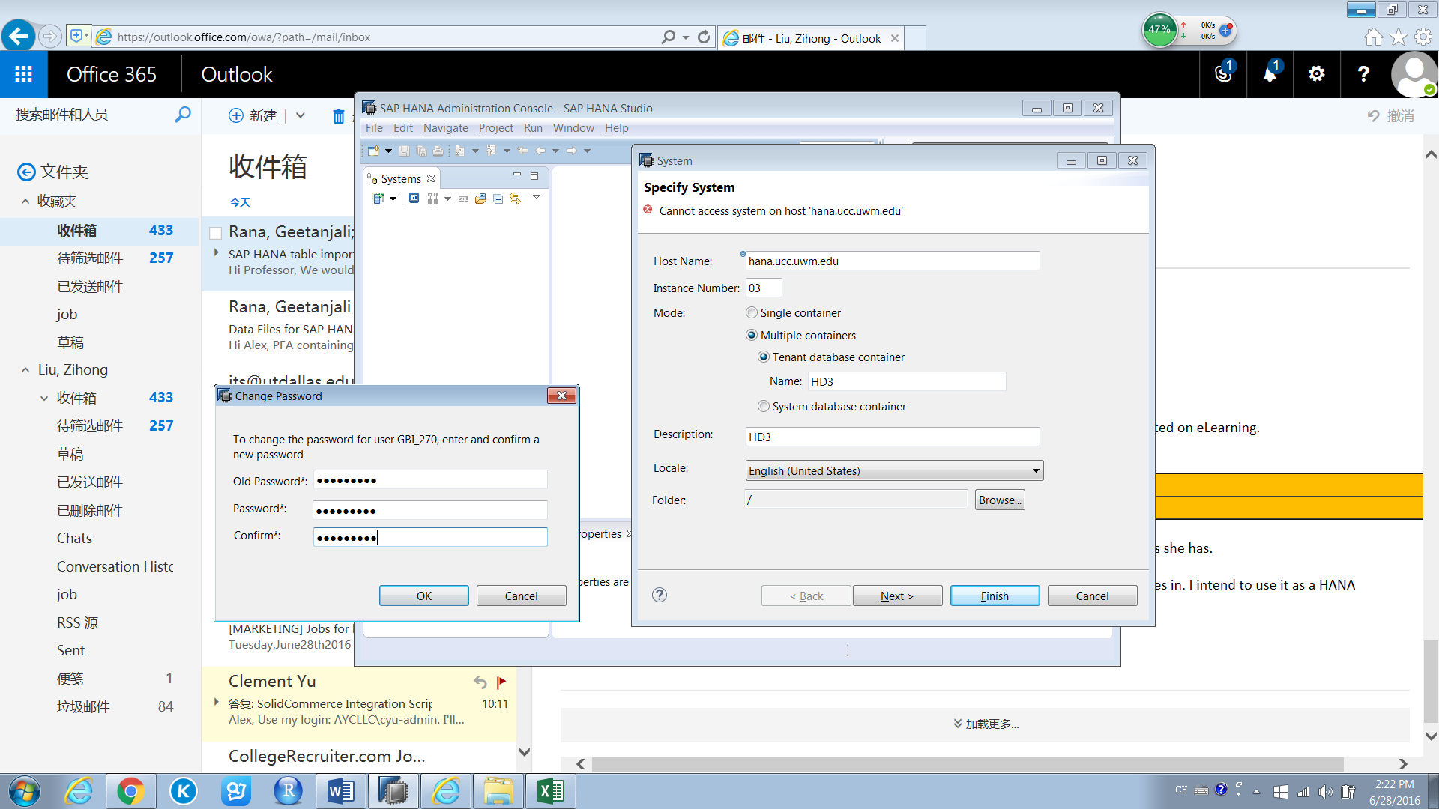

1. Click “File” then Click “Import”, then click “SAP HANA Content” and select Data from Local File.

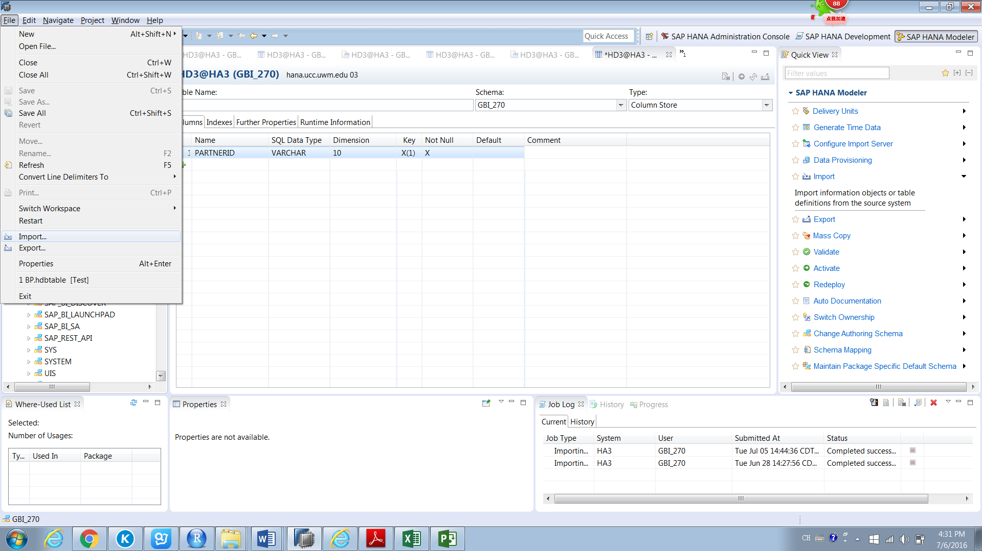

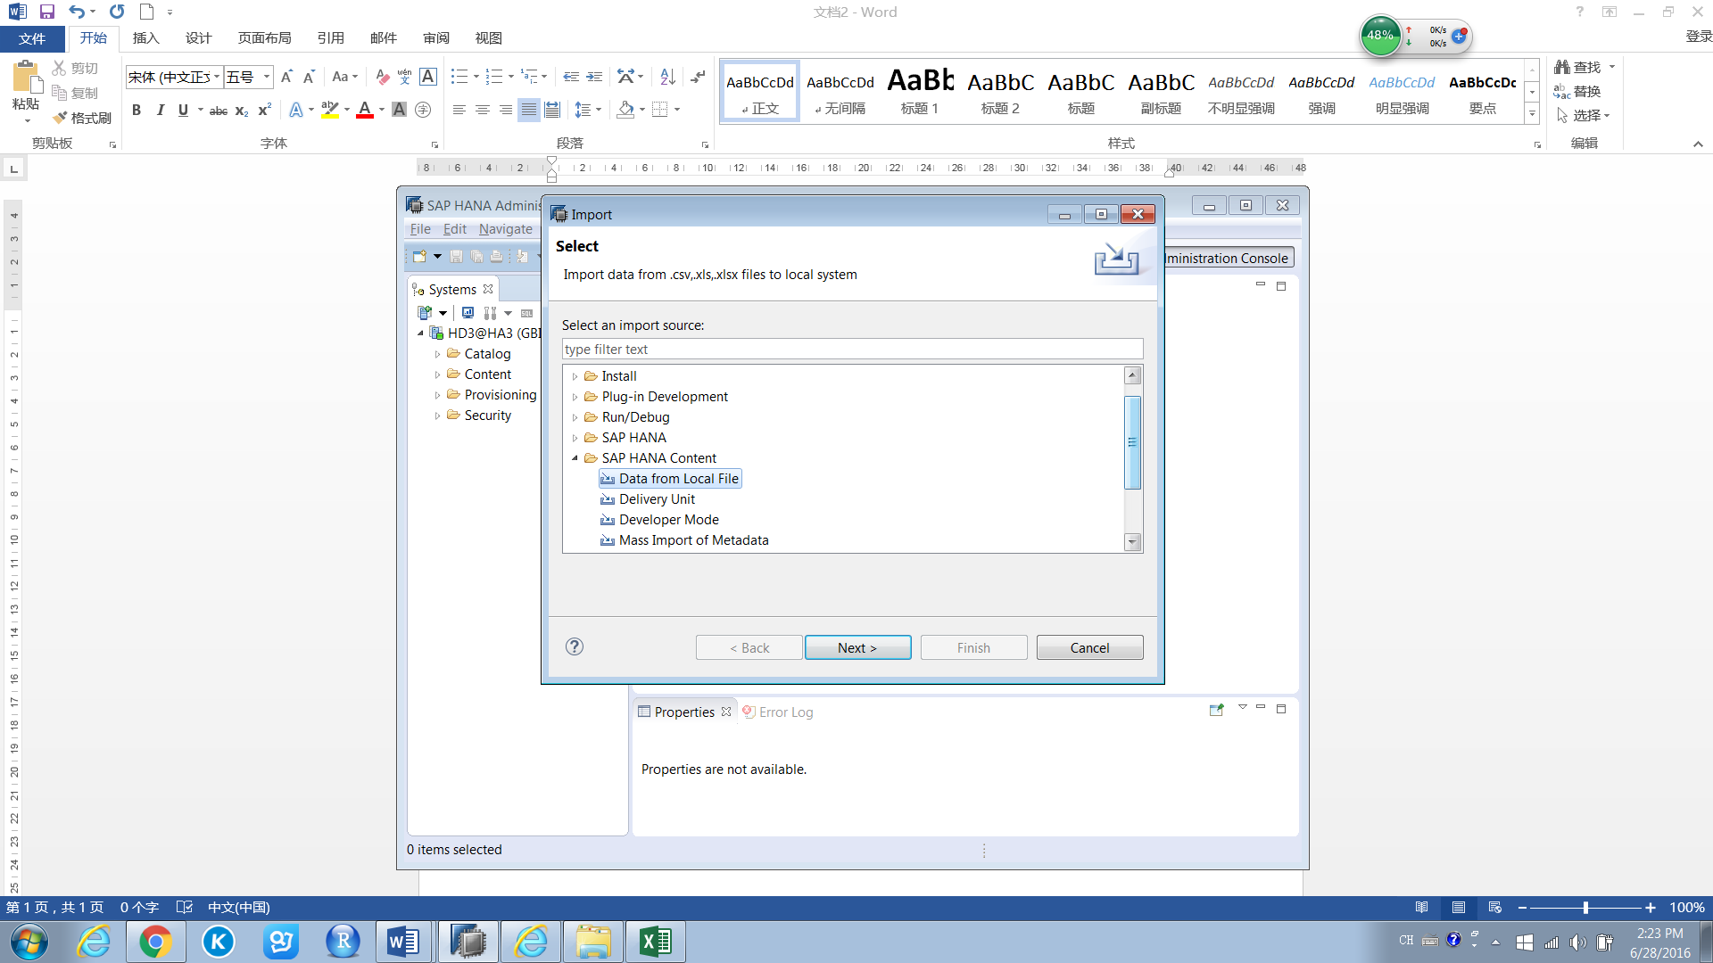

1. Choose the system then click Next

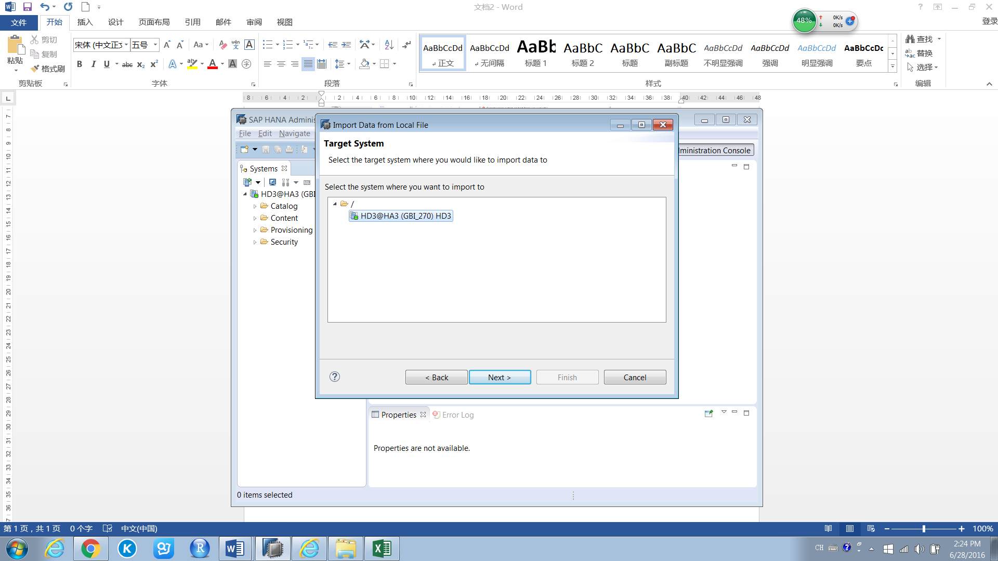

1. Click Browse to choose the data file. Click the check box of “Header row exists”, “Import all data” and “Ignore leading and trailing white-space(s) in file”

Select your user name in the drop-down box of “New Schema” and input your table name

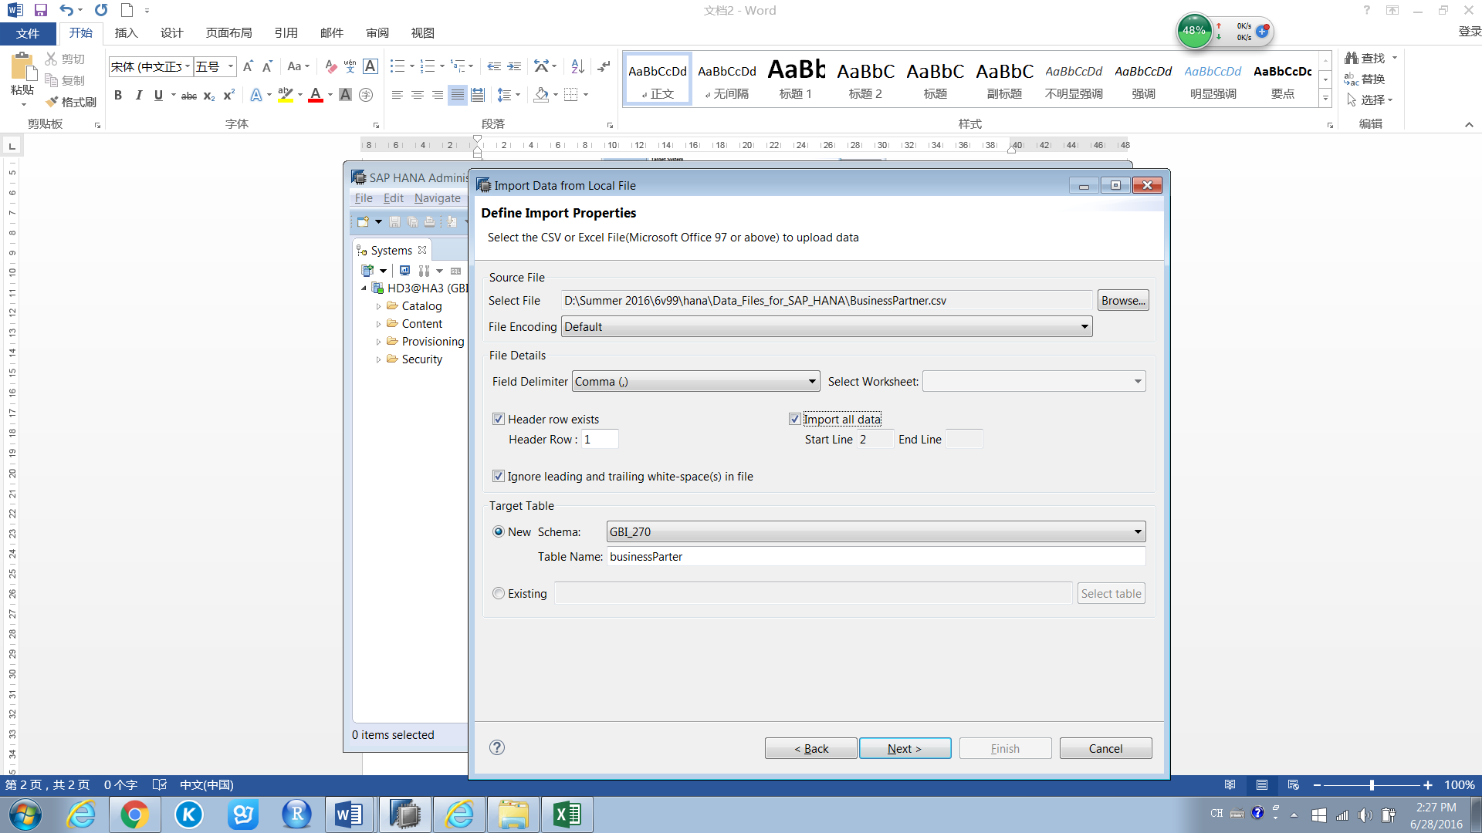

1. Click the “Key” for Primary Key then click Finish

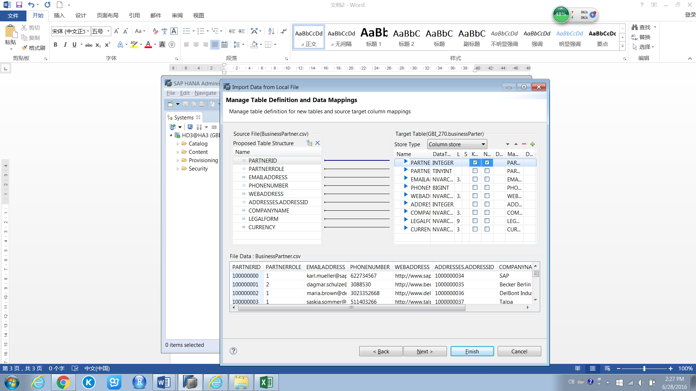

1. You can see the data in the Table under your user name

